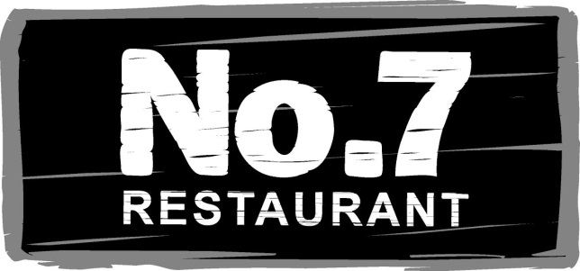

Stone Baked Pizza Menu

FOCACCIA 95
With garlic oil, balsamic caramelized onions, feta, mozzarella & oregano – perfect for sharing between 2-4 people as a starter

CHEESY GARLIC PIZZA 70
With garlic butter & mozzarella

NAPOLITANA 75
Tomatoes, Mozzarella, Basil

NO7 PIZZA 95
Mushrooms, Anchovies and Black Olives

CLASSIC HAWAIIAN 95
Ham, Pineapple & Mozzarella

BBQ CHICKEN 95
With mozzarella & chicken in a BBQ sauce

REGINA 95
With ham, mushrooms and mozzarella

VEGGGIE SUPREME 115
With mushrooms, sliced onions & tomatoes, mixed peppers and a drizzle of home-made pesto

